实验七：

1. 网络拓扑图

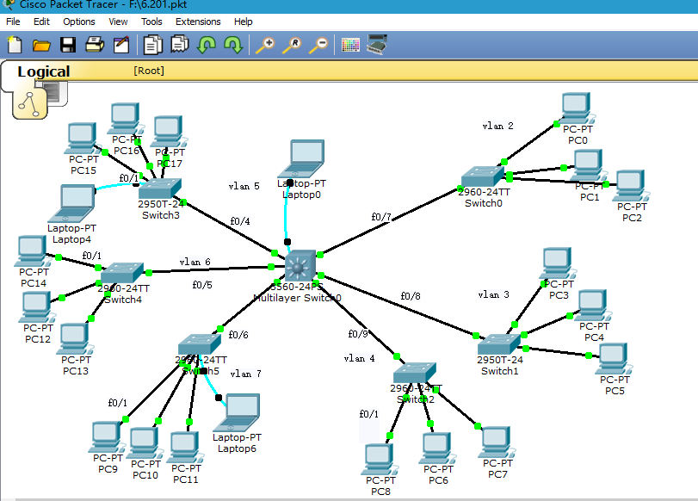

1. PC配置

|  |  |
| --- | --- |
| PC0 | IP:192.168.1.2 |
| PC1 | IP:192.168.1.3 |
| PC2 | IP:192.168.1.4 |
| PC3 | IP:192.168.2.2 |
| PC4 | IP:192.168.2.3 |
| PC5 | IP:192.168.2.4 |
| PC6 | IP:192.168.3.2 |
| PC7 | IP:192.168.3.3 |
| PC8 | IP:192.168.3.4 |
| PC9 | IP:192.168.4.2 |
| PC10 | IP:192.168.4.3 |
| PC11 | IP:192.168.4.4 |
| PC12 | IP:192.168.5.2 |
| PC13 | IP:192.168.5.3 |
| PC14 | IP:192.168.5.4 |
| PC15 | IP:192.168.6.2 |
| PC16 | IP:192.168.6.3 |
| PC17 | IP:192.168.6.4 |

1. 配置过程

1、二层交换机的配置

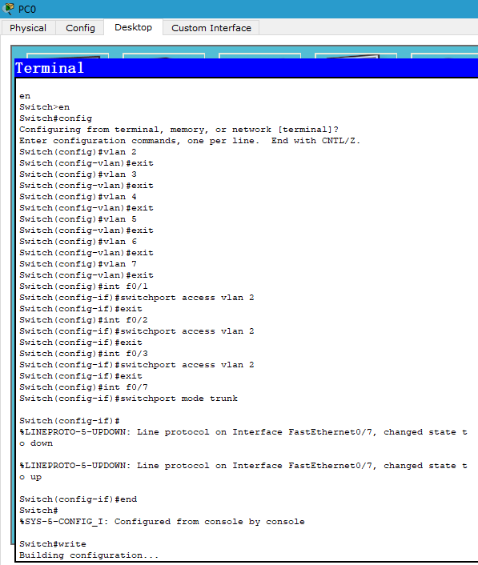

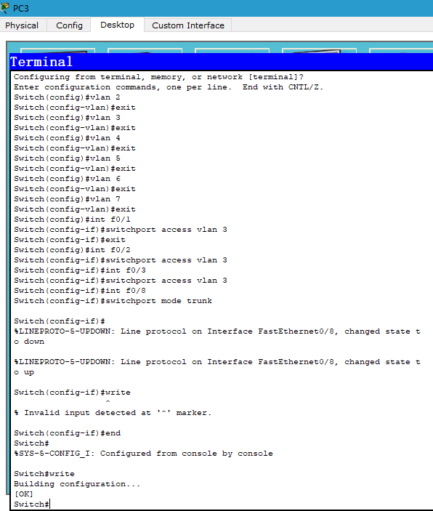

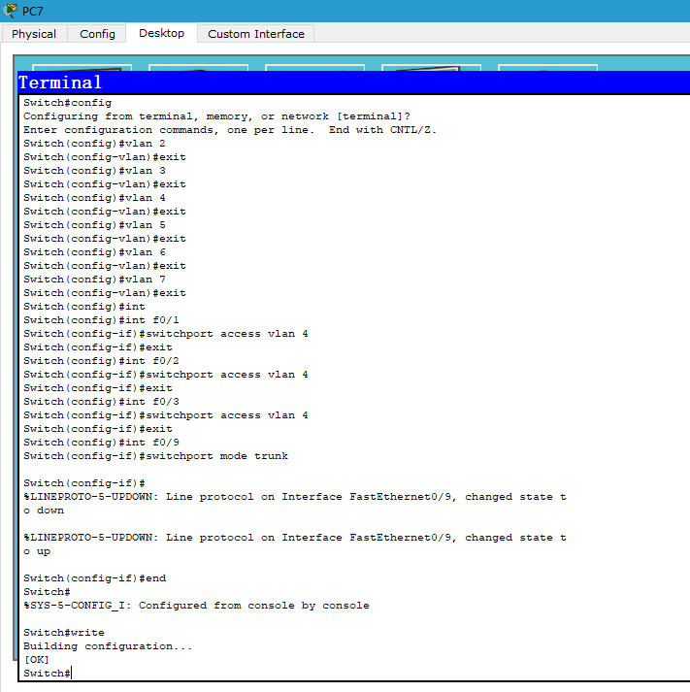

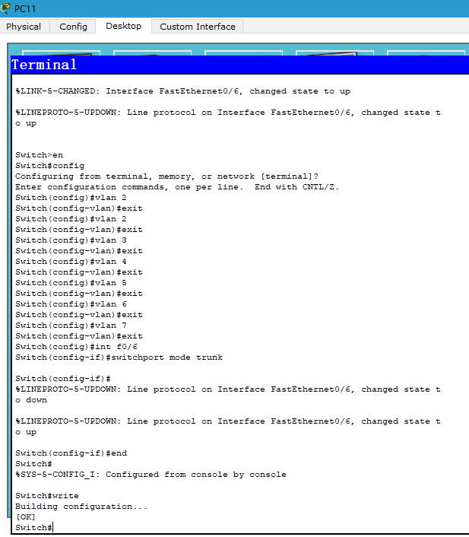

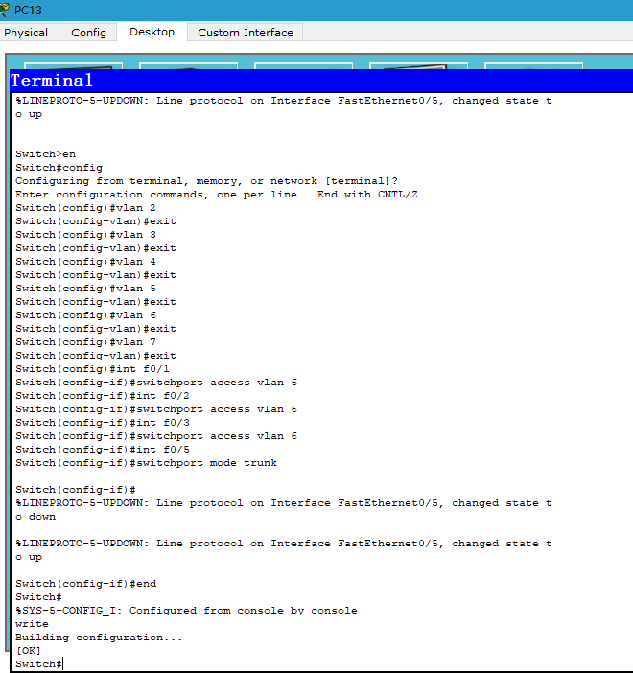

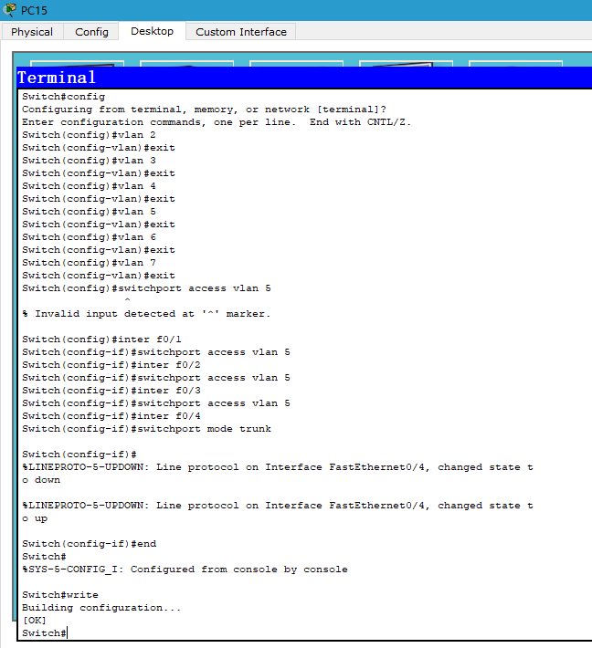

2、三层交换机的配置

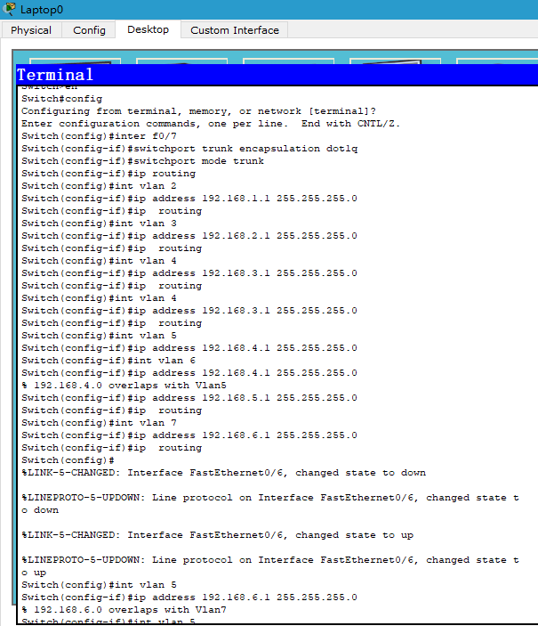

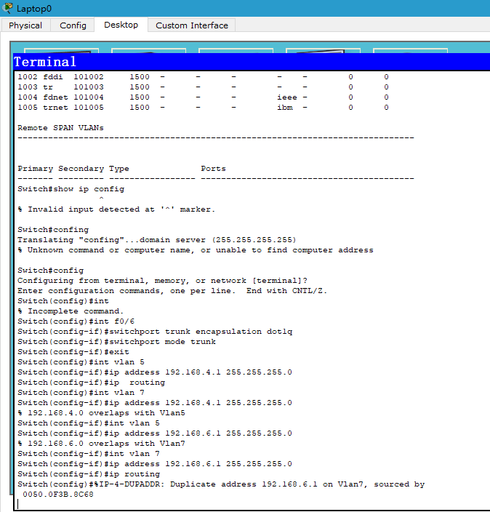

1. 验证：

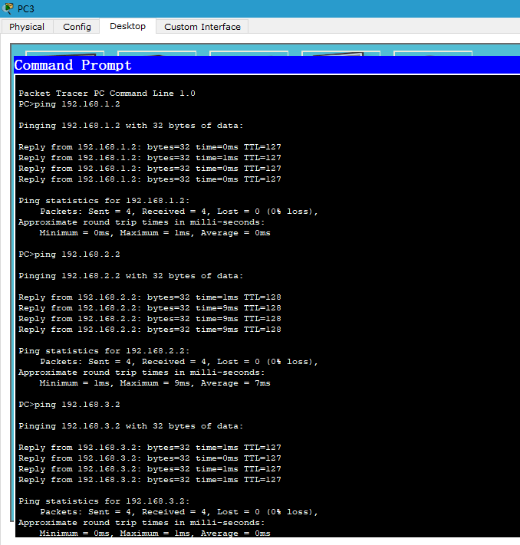

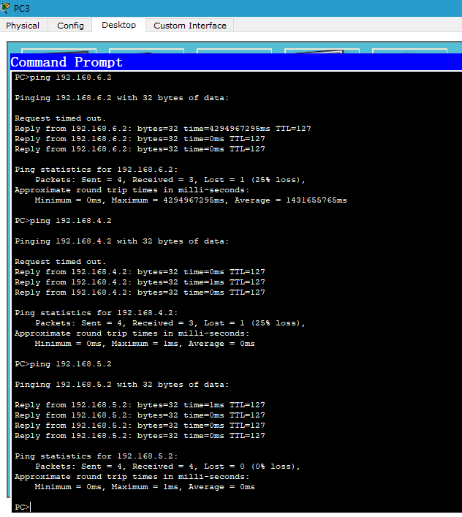

验证成功，实验成功